Color image presentation of signed scalar fields.

Guennadi Levkine (email hlevkin@gmail.com)
Victoria Levkine (email mst@mathship.com)

Mathship Technologies
Gibsons, BC, Canada

Abstract. In this article is presented method of colorizing of grayscale images. It is helps to get more visual information about scalar field intensity distribution. It demonstrated by example of solar magnetogram, which grayscale image transformed to color one.

Key words: scalar field, visual presentation, image processing

1. Introduction – scalar field presentation.

Scalar field of two variables is defined in [1], section 14.1. In that book they defined different methods of these fields presentation. We use here tables with (x, y) coordinates as column and rows indices. Let’s define scalar field as matrix A with number of rows h and number of column w. Table is presented as matrix A:

A(0,0) | A(0,1)
A(1,0)
 |  |  |  |  |  |  | A(h-1,w-1)

There are scalar field values inside cells of the matrix. We treat this matrix as a grayscale image (look at [2]).

2. Algorithm for signed scalar field colorizing.
It is known that it is very convenient to represent two dimensional scalar fields by grayscale images. But very often scalar fields have signed values. The best presentation of such fields are color images, for negative point one color and for positive point another one.
There is no special functions for transformation of grayscale images to colored ones (look at [3]).
We developed algorithm for such image colorizing. This algorithm transforms matrix of scalar field into two matrices P and N, which keeps positive and negative parts of scalar field.

But for that we have to know brightness, which corresponds to zero value of scalar field.
This brightness noted as BZero. Here is pseudo code of that algorithm:

Read matrix A with signed scalar field
Allocate matrices M and P and assigned them to zero
For i passed through all rows
For j passed through all column
If A (i , j) <= Bzero then M (i, j) = A (i , j)
Else M (i, j)=0
If A (i , j) > BZero then P (i, j) = A (i , j)
Else P (i, j)=0
End for
End for
Allocate color image C
Assign M to Green color plane
Assign P to Red color plane
Assign zero to Blue color plane
Save C in a file

3. Python Program, which implements colorizing algorithm.

#==============================================
# version 3.8 of Python
# version 4 of OpenCV
# run in Windows 7 environment

import numpy as np
import cv2
brightness_zero = 128
fname='20150620_001500_1024_HMIB_bw.jpg';
print(fname)
mg0=cv2.imread(fname, 0)
height,width = mg0.shape
print(mg0.shape)
#==============================================
#create mgPlus and mgMinus
mgPlus=np.zeros( (height,width), np.uint8)
mgMinus=np.zeros( (height,width), np.uint8)
mgBlue=np.zeros( (height,width), np.uint8)
mgColor = np.zeros( (height,width,3), np.uint8)
#==============================================
for i in range(0, height):
for j in range(0, width):
if mg0[i][j] > brightness_zero:
mgPlus[i][j]=mg0[i][j]
else:
mgPlus[i][j]=0

if mg0[i][j] <= brightness_zero:
mgMinus[i][j]=mg0[i][j]
else:
mgMinus[i][j]=0
#==============================================
mgPlus=mgPlus- brightness_zero-1
mgPlus=mgPlus*2+2
mgMinus= (255 - mgMinus)
mgMinus=mgMinus- brightness_zero
mgMinus=mgMinus*2+2
mgColor[:,:,0] = 0
mgColor[:,:,1] = mgMinus
mgColor[:,:,2] = mgPlus
#==============================================
cv2.imwrite("mgColor.ppm", mgColor)
cv2.imwrite("mgPlus.pgm", mgPlus)
cv2.imwrite("mgMinus.pgm", mgMinus)

input("push enter to finish...")

4. Solar magnetograms as an Example of scalar field colorizing.

Magnetogram images are representing perpendicular projection of Magnetic Field (MF) to the Sun surface. If projection value is negative, it means that direction of MF is inside the Sun. Otherwise MF directs outside the Sun surface.
In SDO archive ([6]) they saved as unsigned byte images. Look at an example in Picture 1, where dark areas are corresponding to negative projections and bright areas are corresponding to positive projection of MF.
After colorizing using our algorithm we got color image Picture 2. Here are negative values are coding by green colors and positive values are red. It obvious that color picture gives much more details. (Brightness equals to128 corresponds to zero MF)
Similar picture found in [7] (here negative values are blue):
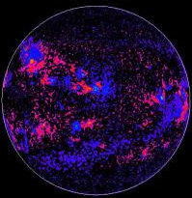

5. Conclusion.

This method of scalar field images colorization gives a lot more information about signed scalar fields. Researchers can interpret such colorized images much better. For that they only need to know which brightness corresponds to zero value of scalar field.

6. Acknowledgments.

We gratefully acknowledge SDO for opportunity copying of magnetograms from their archive.
We also acknowledge developers of OpenCV library, which functions we used for our
algorithm implementation.

Literature:

[1] James Stuart, “Calculus. Early Transcendentals”, Brooks/Cole, 2008

[2] Gonzales “Digital Image Processing” (4th Edition), 2017
[3] Gonzales “Digital image processing using Matlab”, 2009

[4] https://docs.opencv.org/4.2.0/
[5] http://solar-center.stanford.edu/solar-images/magnetograms
[6] https://sdo.gsfc.nasa.gov/data/
[7] https://www2.hao.ucar.edu/Education/Sun/solar-magnetogram

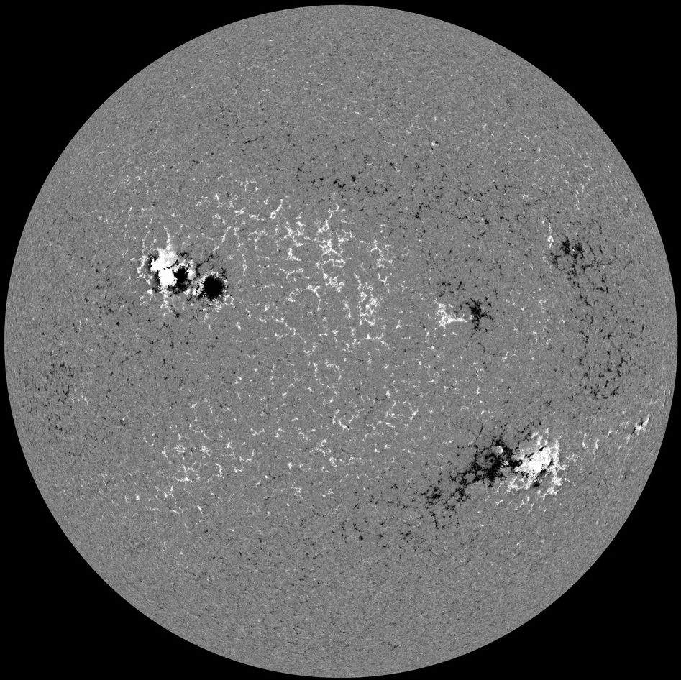

Picture 1

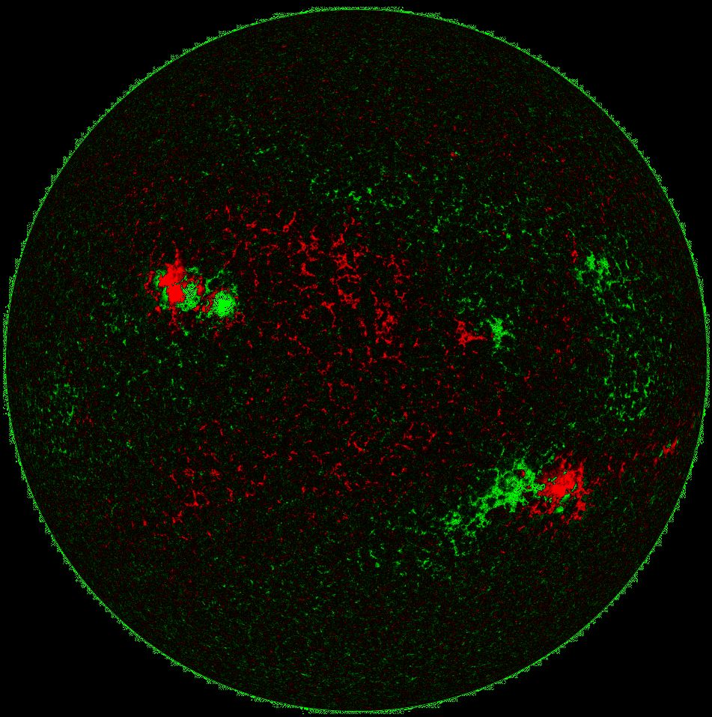

Picture 2

